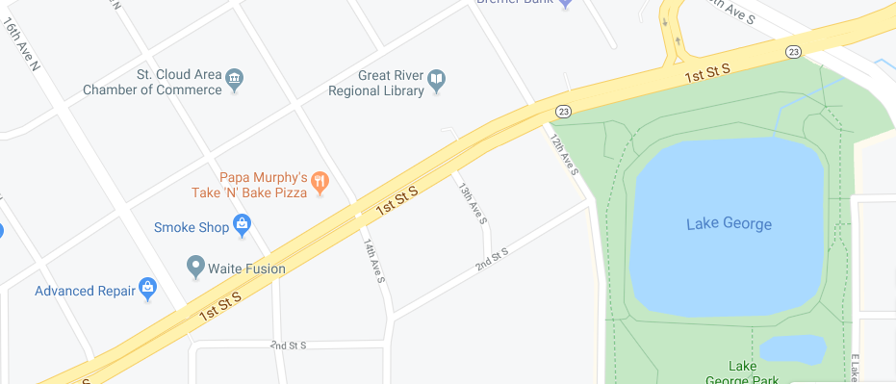  St. Cloud Area  Chamber of Commerce  Building | February 10, 2020!  1411 West Saint Germain St, Suite 105  St. Cloud, MN 56301  PH: 320-253-3715  FAX: 320-252-2567  Phone and fax will remain the same

